Student Name: Ta Quang Tung

Student ID: 104222196

Tutorial time: Saturday 3:00 P.M.

Date of submission: 18/6/23

**COS20019 – Cloud Computing Architecture - Assignment 1B**

**Marking scheme**

|  |  |  |
| --- | --- | --- |
| **Infrastructure Requirements** | **Mark** | **Page** |
| VPC with 2 public and 2 private subnets | .5 | 7 |
| Correct Public and Private Routing tables with correct subnet associations | 1 | 8 |
| Security groups properly configured and attached. | 1 | 9-11 |
| Network ACL properly configured and attached | 1.5 | 30-32 |
| Correct Web server and Test instances running in correct subnets | .5 | 13, 19 |
| Database schema as specified | .5 | 29 |
| Database running in correct subnets | 1 | 26 |
| S3 objects publicly accessible, using proper access policy | .5 | 36 |
| **Functional Requirements** |  |  |
| album.php page displayed from EC2 Web server | 1 | 38 |
| Provided URL is persistent (Elastic IP Association) | .5 | 17 |
| Photos loaded from S3 with matching metadata from RDS | 1 | 38 |
| Web server instance reachable from Test instance via ICMP | 1 | 5 |
| **Deductions** |  |  |
| Documentation not as specified or poorly presented (up to minus 20) |  |  |
| Serious misconfigurations of AWS services being used (up to minus 20) |  |  |

Table of contents

Table of contents 2

Website URL 3

Data records 4

Successful ping from TestInstance to WebServer 5

1 Infrastructure deployment 6

1.1 Create a VPC 6

1.2 Create security groups 9

1.3 Create EC2 instances 12

1.3.1 Bastion/Web server instance 12

1.3.2 Test instance 18

1.4 Create RDS instance 21

1.5 Network ACL 30

2 Functional requirements of Photo Album website 33

2.1 Photo storage (S3) 33

2.2 Photo meta-data in RDS Database 37

2.3 Photo Album website functionality 38

Website URL

<http://ec2-44-216-98-59.compute-1.amazonaws.com/cos80001/photoalbum/album.php>

Data records

Two data records are present in the database.

Successful ping from TestInstance to WebServer

The Test Instance can ping the Web Server.

1. Infrastructure deployment
   1. Create a VPC



Create the VPC: (1) the name follows the correct pattern [FirstNameInitial][LastName]VPC, (2) set the CIDR block, (3) the subnet names indicate the region us-east-1

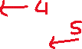

Create the VPC: (4) & (5) specify two public and two private subnets, (6) associate each subnet with their address blocks.

The VPC has been successfully created, and the subnets have been associated with the correct route tables.

* 1. Create security groups

Create the Test Instance security group that allows traffic from all sources.

Create the Web Server security group that allows HTTP and SSH traffic from all sources, and ICMP traffic from Test Instance.

Create the Database Server security group that allows MySQL traffic from the Web Server.

* 1. Create EC2 instances
     1. Bastion/Web server instance



Create the Bastion/Web Server instance from Amazon Linux 2 AMI (HVM), SSD Volume Type



Create the Bastion/Web Server instance: (3) set the type to t2.micro, (4) assign a key pair, (5) place the instance in public subnet 2.



Create the Bastion/Web Server instance: (6) assign the web server security group.



Create the Bastion/Web Server instance: (7) configure a user data script to install the Apache server.

Allocate an Elastic IP address in the us-east-1 region.



Assign the new Elastic IP address to the Bastion/Web Server instance.

* + 1. Test instance



Create the Test Instance.



Create the Test Instance: assign a key pair, place the instance in private subnet 2, and assign the Test Instance security group.



1. SSH into the Test instance from the Web Server instance, then (2) ping the Web Server’s private Ipv4 address.
   1. Create RDS instance

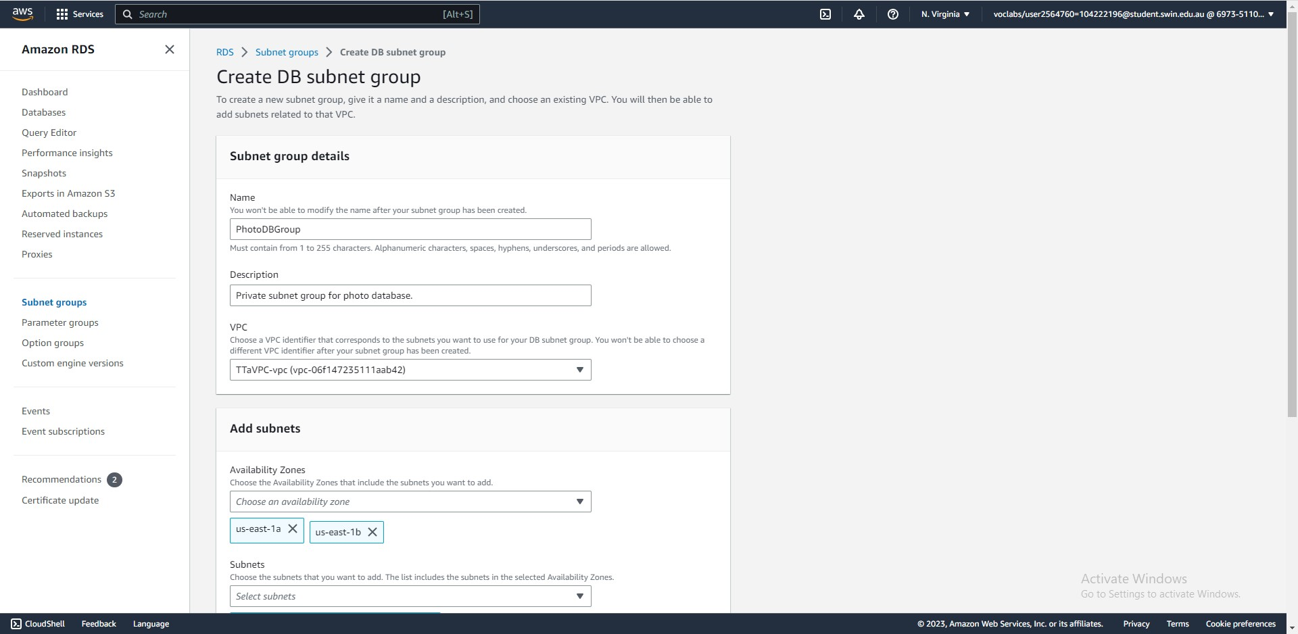

Create a DB subnet group in the VPC that spans both Availability Zones.

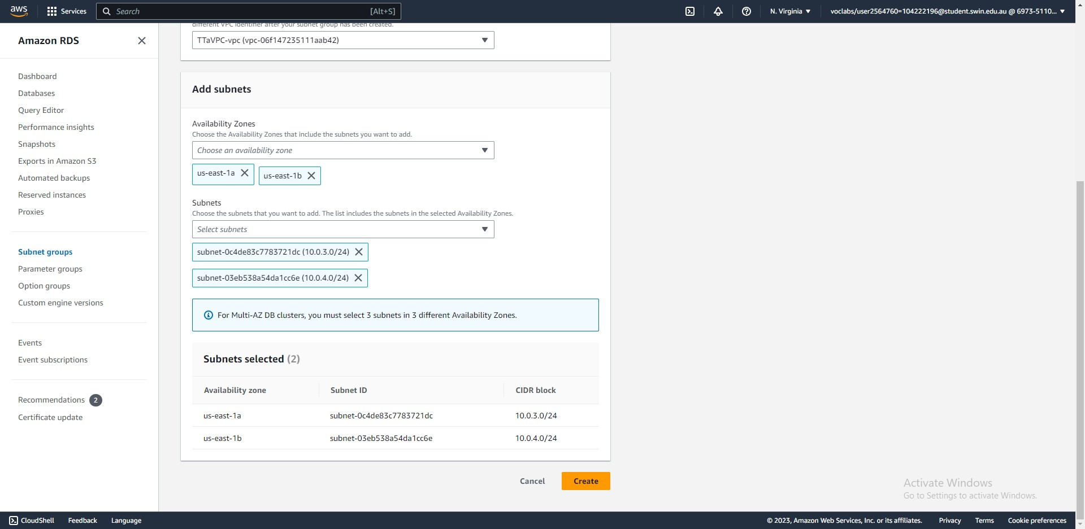



Assign both private subnets to the subnet group.

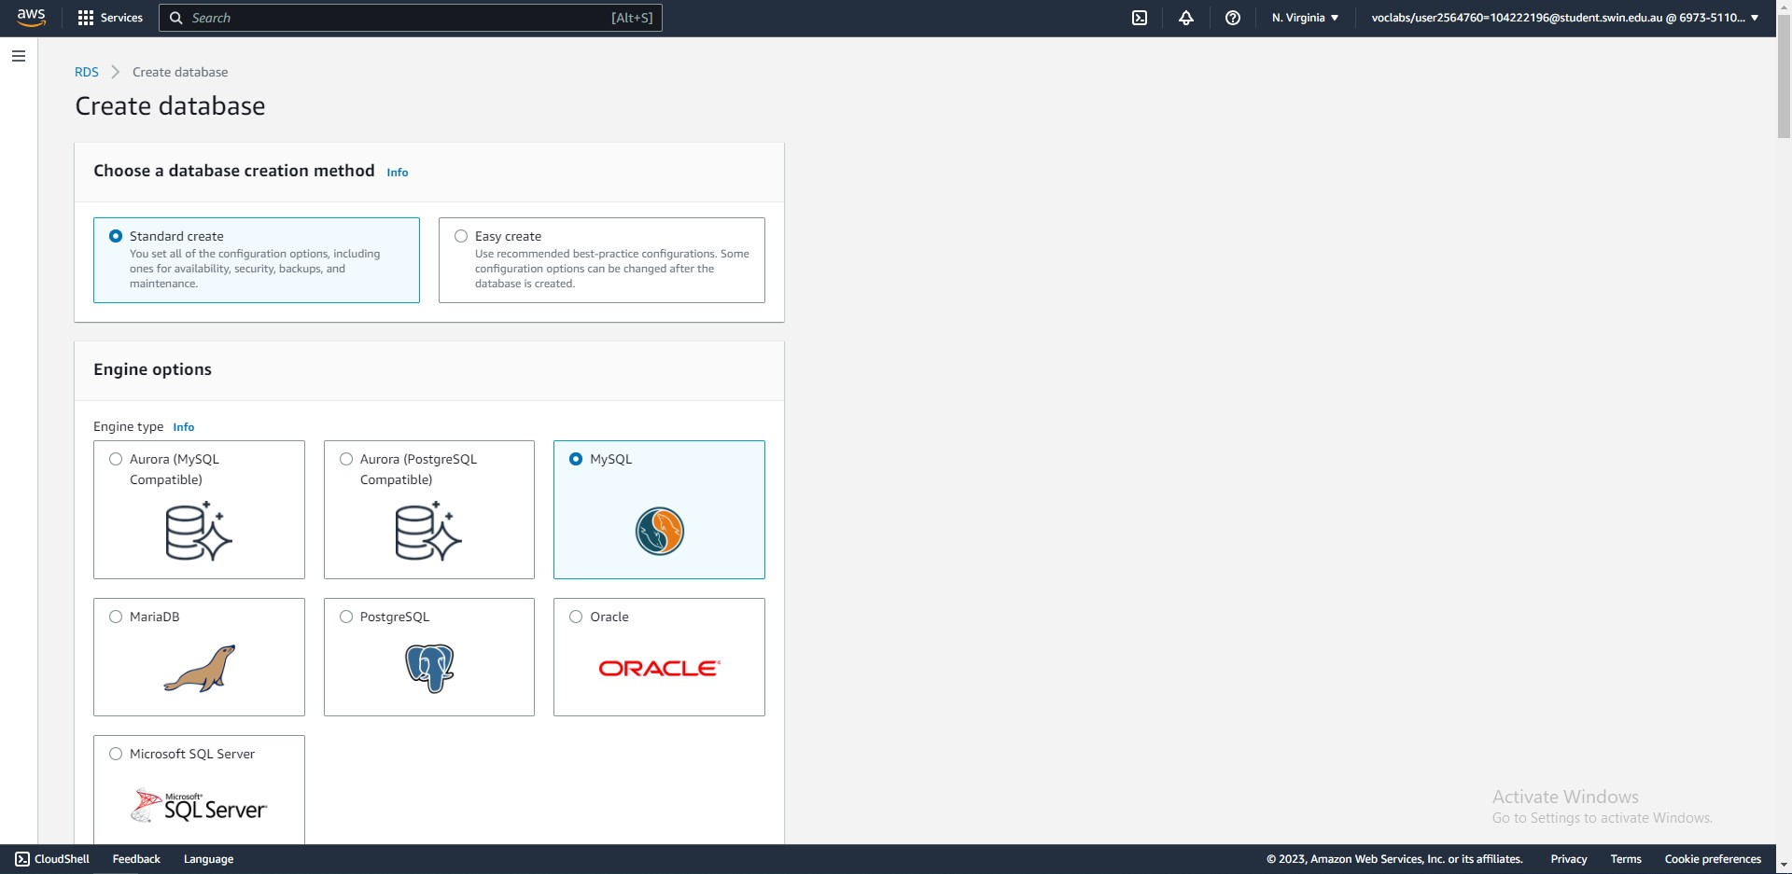



Create the RDS instance: (1) choose MySQL.

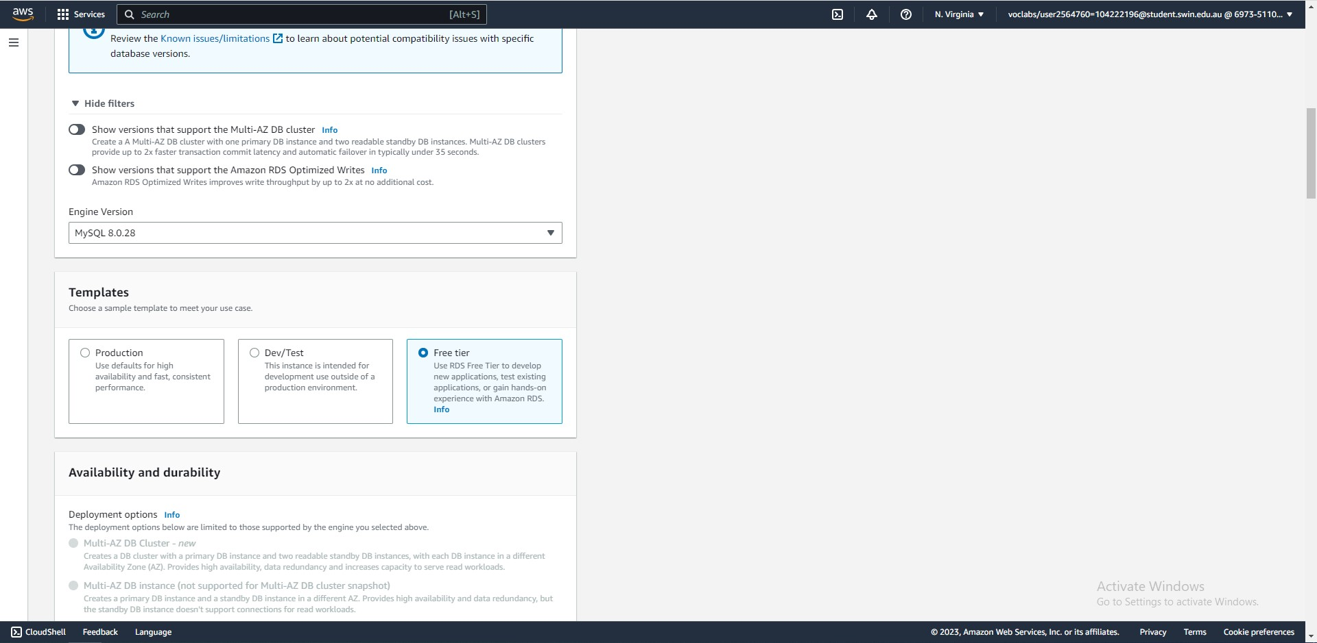



Create the RDS instance: (2) choose engine version 8.0.28, (3) choose the free tier template.

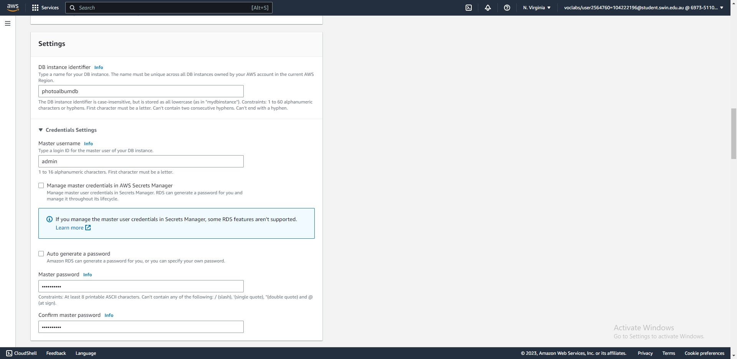



Create the RDS instance: (4) configure DB credentials.

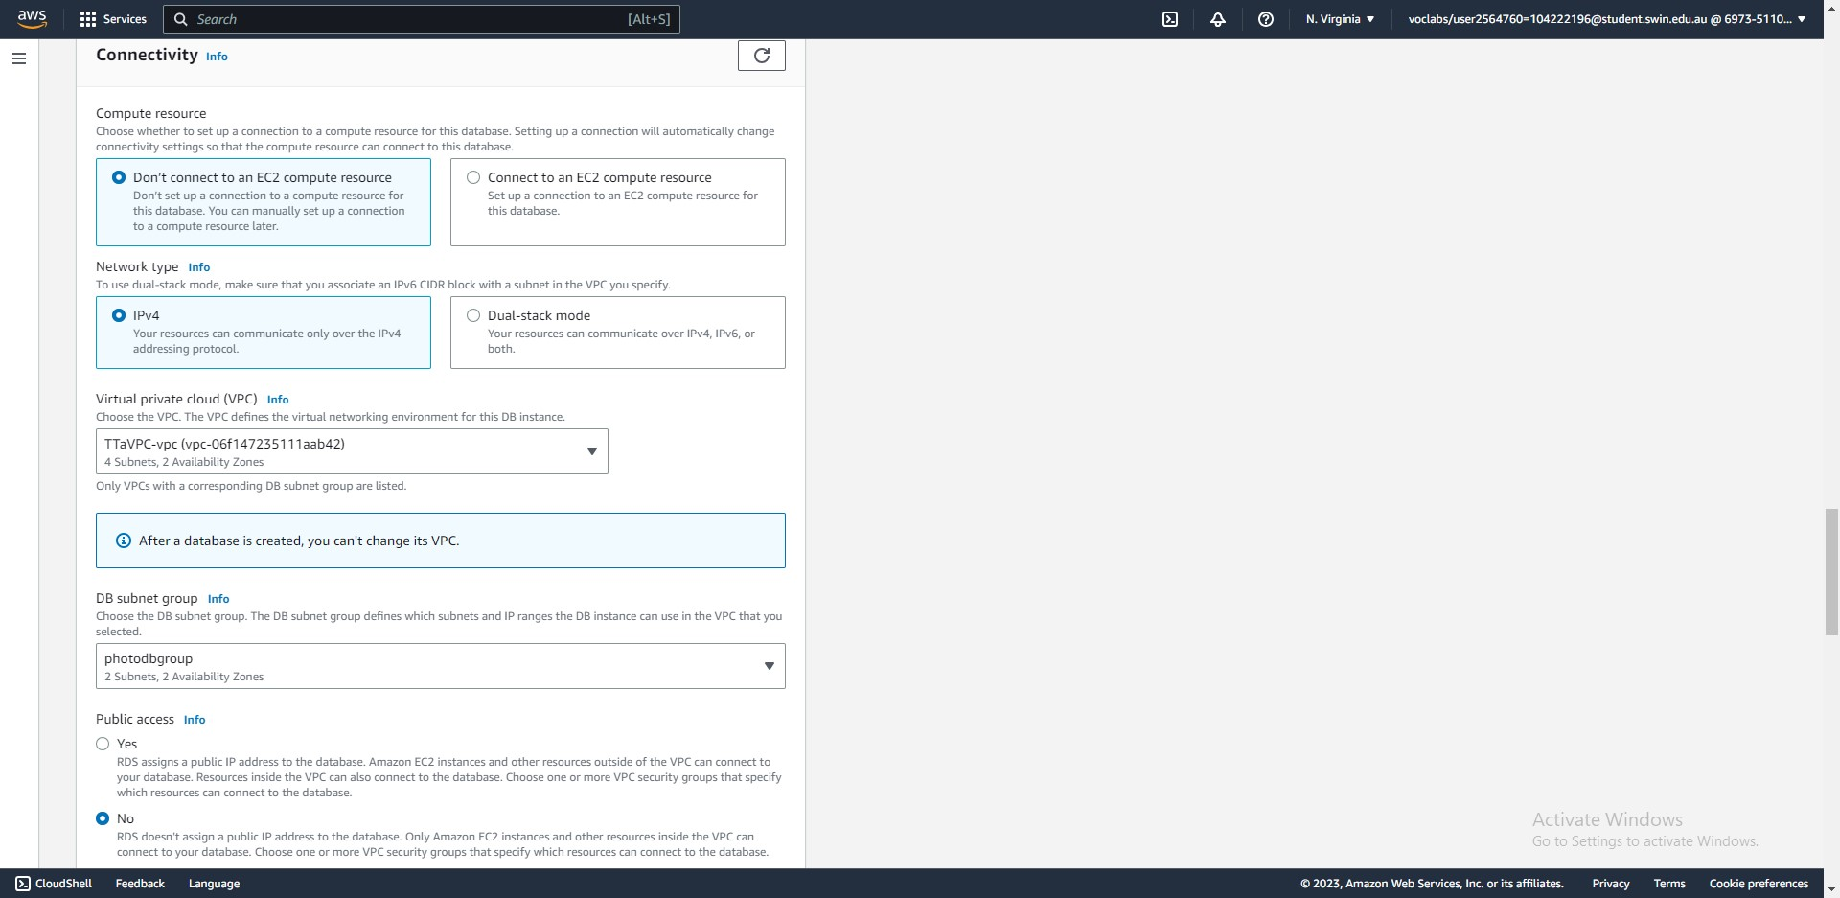



Create the RDS instance: (5) place the DB in the VPC, (6) assign it the private subnet group, (7) block public access.



Create the RDS instance: (8) assign the DB Server security group, (9) choose Availability Zone A.

The RDS instance has successfully been created.



After setting up phpMyAdmin on the Bastion/Web Server instance, access the database server and create a table named ‘photos’ with the above structure. The SQL statement to create the table is:

CREATE TABLE photos (

id INT NOT NULL AUTO_INCREMENT PRIMARY KEY,

title VARCHAR(255), description VARCHAR(255),

date DATE, keywords VARCHAR(255), s3_photo VARCHAR(255)

);

* 1. Network ACL

Create the Network ACL for public subnet 2 with the above inbound rules.

Rule 1, 2, 3 allow HTTP, HTTPS, and SSH traffic from anywhere to reach the subnet.

Rule 5 allows ICMP traffic from the Test Instance to reach the subnet.

Rule 6 allows all TCP traffic from the Database Server to reach the subnet. This lets the database reach the web server.

Rule 7 allows all TCP traffic from the Test Instance to reach the subnet. This lets the Test Instance reach the bastion/web server instance.

Allow all outbound traffic because this does not affect security.

1. Functional requirements of Photo Album website
   1. Photo storage (S3)

Create an S3 bucket in the us-east-1 region to store photos.



Allow public access to the bucket and its content.

Upload 2 photos to the S3 bucket.

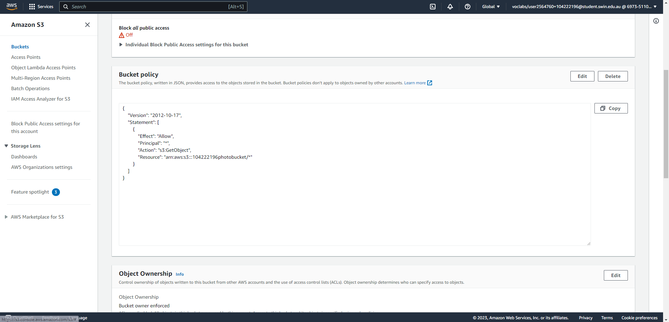



Create an access policy that allows anyone to access the bucket objects. Effect “Allow” grants permission to perform the action. Principle “*” lets anyone perform the action. Action “s3:GetObject” restricts the action to only reading the objects. Resource “arn:aws:s3:::104222196photobucket/*” indicate that every object in this bucket can be read.

* 1. Photo meta-data in RDS Database

Add 2 records corresponding to the images on S3 into the ‘photos’ table. This is performed with the INSERT INTO query.

* 1. Photo Album website functionality

After making the necessary modifications in the constants.php file and uploading the source code to the Web Server, the page is accessible at <http://ec2-44-216-98-59.compute-1.amazonaws.com/cos80001/photoalbum/album.php>